North Atlanta Equestrian Camp
. 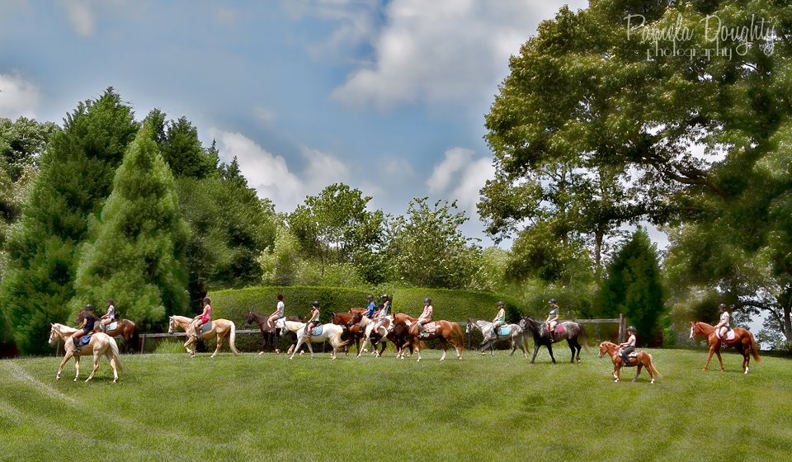
Regular Camp _____ May 29th- June 3rd Regular Camp _____ June 12th - 16th
Regular Camp _____ June 26th - 30th Regular Camp _____ July 11th - 15th
Eventing Camp _____July 17th – 22nd $TBA Regular Camp July 24th - 28th
We are a family farm in GA that offers horse camp for ages 5 - 18. We proudly offer more riding time and better, safer instruction than any other camp. Our camp's emphasis is on summer fun, correct English riding, and making new friendships in a happy and safe environment. We only use safe quality horses and ponies. We have something to fit every size of rider and will match up your child properly.
An average day at camp includes a two hour horsemanship and riding lesson in the morning followed by a horse craft... and then lunch. Afternoon lesson includes a horse knowledge session and trail riding etc. We will have structured days with lesson plans, appropriate to each age level, for each day. Our instructors are adults with years of teaching and riding experience. Camps are kept small so that each rider gets the maximum out of their daily riding lesson.
Camp hours are 9.30.am - 1.30.pm. Campers are expected to wear long pants and a shoe with a heel. Bring a sack lunch with plenty of cold drinks. Helmets are required. A change of clothes and a swim suit is advisable. Cost - $350. *Discount given for early bird registration. Arrangements can be made for before and after camp care. **Option 1: Pay in full before May 1st , 2017 and only pay $250.00 per child. Option 2: Pay $100.00 non-refundable deposit to secure a session for your child at the regular rate of $275.00. Balance of $175.00 is due upon the first day of camp by 8:30 am.****Option 3: Pay $300.00 the first day of camp if any spots are available. I cannot hold spots, they are on a first come, first served basis. When I receive the payment and documents your spot is secured. Thank-you.
Please get your registration in early. We look forward to meeting our new campers!
Elizabeth Southard 118 Old Mill Rd •Cartersville, GA 30120 •770-833-4152 •esouthard2@gmail.com

